# Operational Concept Description (OCD)



**Team 02**

|  |  |  |
| --- | --- | --- |
| **Member Name** | **Role** | **Email** |
| Rajat Verma | Project Manager, Lifecycle Planner, Dev | [rajatver@usc.edu](mailto:rajatver@usc.edu) |
| Preksha Gupta | Software Architect, Operational Concept Engineer | prekshag@usc.edu |
| Mangalore Rakesh Shenoy | Software Developer, Prototyper | mangalos@usc.edu |
| Ankit Gupta | Requirements Engineer, Tester | guptaank@usc.edu |
| Snehal Surendra Desai | Prototyper, Software Developer | snehalsd@usc.edu |
| Lu Wu | Quality Focal Point, Tester | wulu@usc.edu |
| Heidi Negron-Arroyo | IIV and V, Feasibility Analyst | negronar@usc.edu |

**10/15/2016**

# Version History

| Date | Author | Version | Changes made | Rationale |
| --- | --- | --- | --- | --- |
| 10/13/16 | Preksha Gupta | 1.0 | * Added the program model, Benefits Chain diagram, System boundary and environment diagram, current artifacts, infrastructure and workflow, goals and constraints, ERD | * OCD draft to be uploaded before the FCR presentation. |
| 10/15/16 | Snehal Desai | 1.1 | * Added the status of OCD, system capability description, Relation to current system, business workflow for the proposed system, operational and organizational implications | * Final documentation for the FCP-ARB. |

# Table of Contents

Operational Concept Description (OCD) i

Version History i

Table of Contents iii

Table of Tables iv

Table of Figures v

1. Introduction 1

1.1 Purpose of the OCD 1

1.2 Status of the OCD 1

2. Shared Vision 2

2.1 Benefits Chain 3

2.2 System Capability Description 3

2.3 System Boundary and Environment 4

3. System Transformation 5

3.1 Information on Current System 5

3.2 System Objectives, Constraints and Priorities 8

3.3 Proposed New Operational Concept 11

3.4 Organizational and Operational Implications 14

# Table of Tables

Table 1: The Program Model 2

Table 2: Current Artifacts 5

Table 3: Capability Goals 8

Table 4: Level of Service Goals 9

Table 5: Relation to Current System 10

# Table of Figures

*Figure 1: Benefits Chain Diagram ………………………………......................................................**3*

*Figure 2: System Boundary and Environment Diagram ………………………………………………**5*

*Figure 3: VYMA.org Website Workflow………………………………………………………..………..**.5*

*Figure 4: VYMA donations…………………………...……………………………………………..……..**5*

*Figure 5: MailChimp Workflow………………………………………………………………... ………..**5*

*Figure 6: My VYMA(Shutterfly) workflow……………………………………………………. ………...**5*

*Figure 7: Calendar of Events workflow…………………………………………………………………..**5*

*Figure 8: Element Relationship Diagram .......………………………………………………………….9*

*Figure 9: Business Workflow Diagram: Online Registration and Payment System………………**12*

*Figure 10: Business Workflow Diagram: Announcement and Notification System……………….12*

*Figure 11: Business Workflow Diagram: Download Music Notes………………………………….13*

*Figure 12: Business Workflow Diagram: Calendar of Events………………………………… ……**13*

### Introduction

#### Purpose of the OCD

This document provides, in detail, the shared visions and goals of the stakeholders of Verdugo Young Musicians Association. The success-critical stakeholders of the project are Samvel Chilingarian, as the project owner; Lindsey Hansen, the program coordinator, the VYMA Staff and volunteers and the music enthusiasts as users.

#### Status of the OCD

The status of the OCD is currently at the version 1.1 in the development phase. All the sections are completed as per the requirements of the Foundations Commitment Package.

The business workflows for the proposed system are added. The Organizational and Operational Implications have been specified.

### Shared Vision

Our vision involves:

* Reducing *Redundancy* by combining the three Websites.
* Introducing the *Online Registration* and *Payment System.*
* Ease of *Maintenance*.

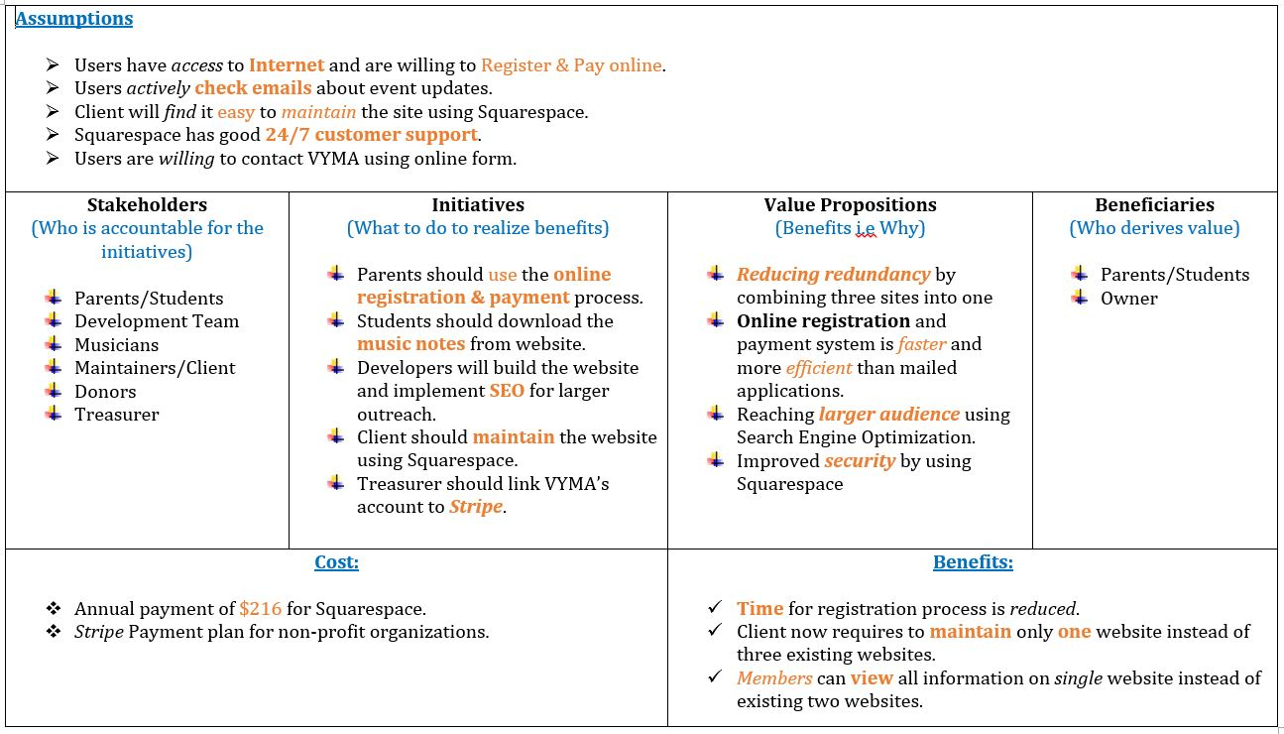

Table 1: Program Model

#### Benefits Chain

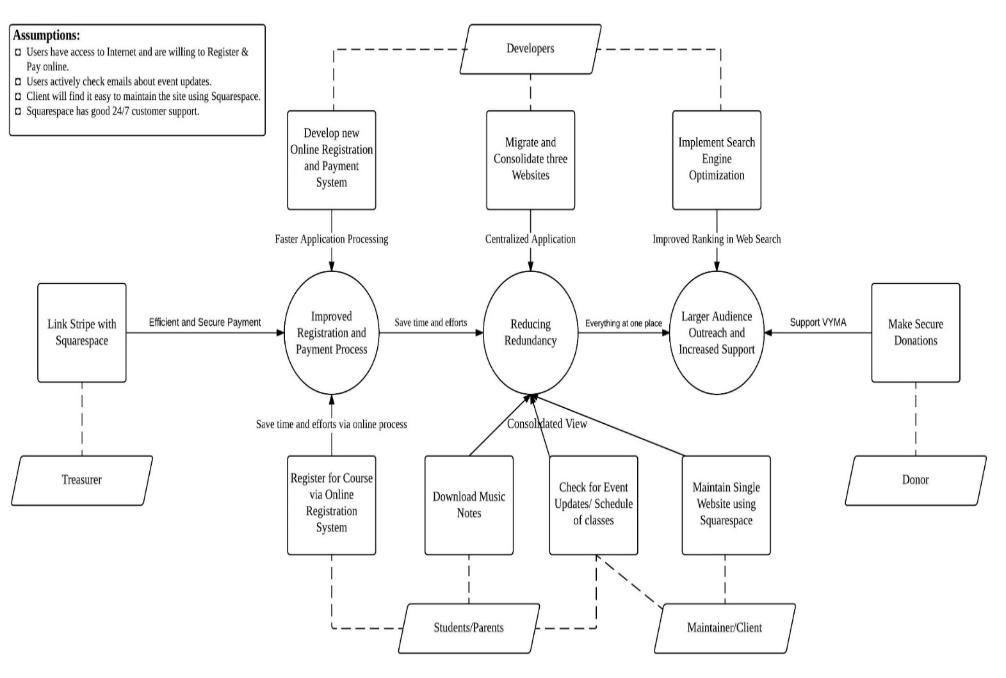

Figure 1: Benefits Chain Diagram

#### System Capability Description

VYMA’s new website will have new features such as online registration and payment system, announcements page, donations page, event calendar with different views, roster with all members’ information and all the data migrated from the previous website.

VYMA’s new website offers a faster and efficient way to register for courses. The website is going to be a one stop for all the VYMA related processes.

VYMA hopes to reach a larger audience by having a new user friendly website. The target customers for the system are the students, parents, musicians and other music enthusiasts.

This system benefits the maintainers by eliminating redundancy and replacing the manual processes by their automated counterparts.

#### System Boundary and Environment

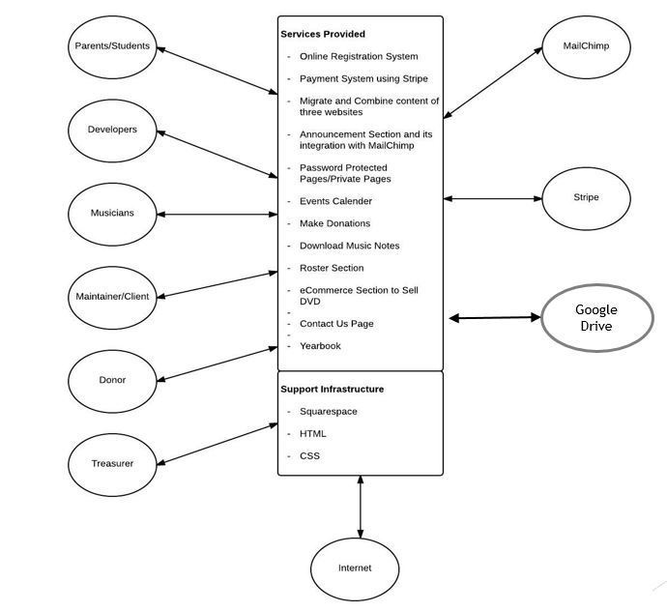

Figure 2: System Boundary and Environment Diagram

### System Transformation

#### Information on Current System

##### Infrastructure

**Software:** The Verdugo Young Musicians Association (VYMA) currently uses multiple services for partially fulfilling their needs.

1. **WordPress** website hosted on Dreamhost (www.vyma.org), where the association disseminates information on their music programs, program tuition and application, events, and donations for prospective/current students, their parents, teachers and donors.
2. **Shutterfly** Sharing website (vymayo.shutterfly.com), password protected website where teachers, current students and parents can sign up for volunteering events, share photos and videos of rehearsals/concerts and download music sheets.
3. **Mailchimp** service used for sending weekly email newsletters and marketing purposes.
4. **Paypa**l is used for payment processing.

##### Artifacts

The current system was created and has been maintained by non-technical people with the help of Content Management Systems and Email Marketing services. No formal documents have been produced during the design phase of VYMA, and the list of artifacts below represent information our team has obtained from conversations with the client, independent research or CSCI 577A class website.

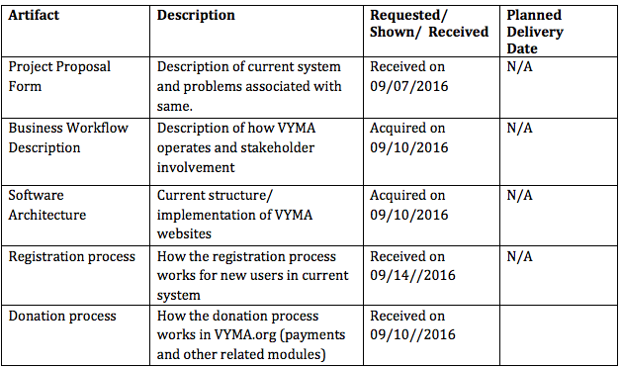

**Table 2: Current Artifacts**

##### Current Business Workflow

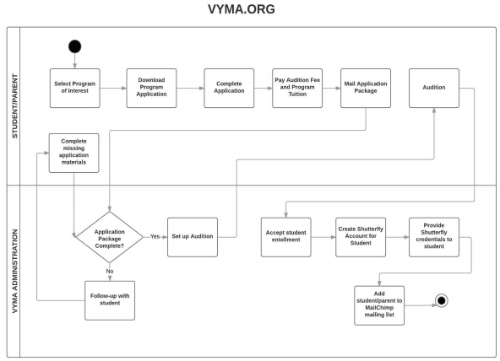

**Figure 3: VYMA.org Website Workflow**

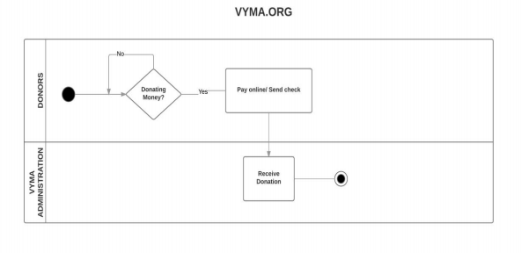

**Figure 4: VYMA donations workflow**

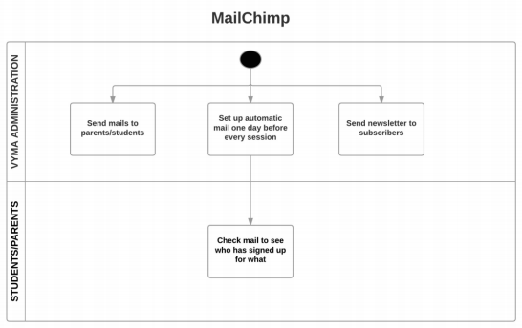

**Figure 5: MailChimp Workflow**

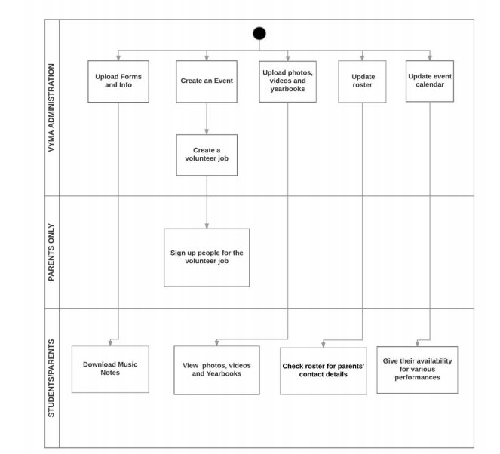

**Figure6: My VYMA(Shutterfly) workflow**

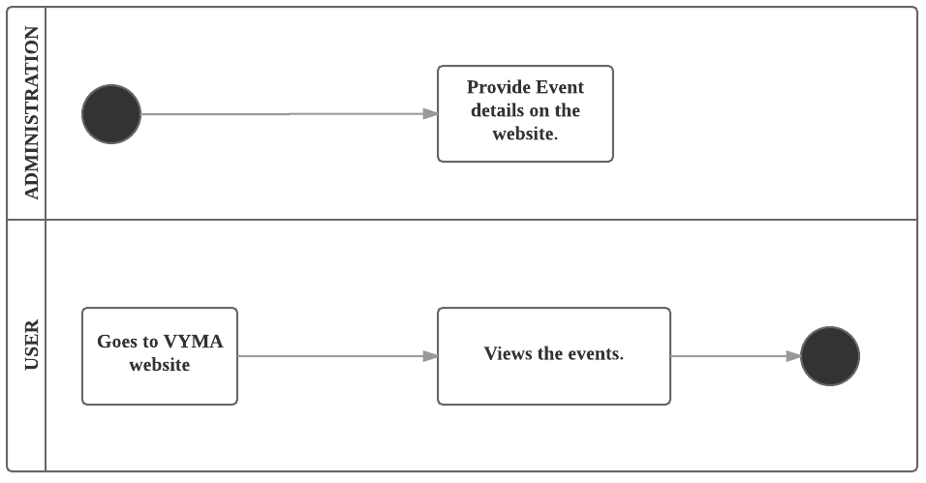

**Figure7: Calendar of Events workflow**

#### System Objectives, Constraints and Priorities

##### Capability Goals

|  |  |
| --- | --- |
| **Capability Goals** | **Priority Level** |
| **OC-1 Online Registration and Payment System:** Students/Parents can register and pay for music courses online. | Must have |
| **OC-2 Consolidate three websites:** User can view all the content on one website instead of three. | Must have |
| **OC-3 Announcement Section:** User can view all the updates and announcements in announcement section and also receives an email notification for the same. | Must have |
| **OC-4 Donations:** Donors can make donations to support VYMA through online payment system | Must have |
| **OC-5 Event Calendar:** User can view schedule of all the classes and events in event calendar. | Must have |
| **OC-6 Maintain Registration Process:** Client/Maintainer can check his email and Google Drive for new applicants and their information. | Must have |
| **OC-7 Download Music Notes:** User can download music notes from password protected page for rehearsals. | Must have |
| **OC-8 Roster:** Parents can view other student’s parent’s details on a password protected page. | Mid Priority |
| **OC-9 Buy DVD:** User can buy DVD of rehearsals and events online. | Low Priority |
| **OC-10 Contact Us Page:** User can contact VYMA administration for feedbacks and concerns. | Low Priority |
| **OC-11 Yearbook:** User can view yearbook through a link on VYMA website. | Low Priority |

**Table 3: Capability Goals**

##### Level of Service Goals

|  |  |  |
| --- | --- | --- |
| **Level of Service Goals** | **Priority Level** | **Referred WinWin Agreements** |
| Receive Notifications for new orders/registration | Must Have | WC_4199 |
| Receive Notifications for the donations made | Must Have | WC_4227 |
| Timely MailChimp Notifications on event updates | Must Have | WC_4210 |
| Mobile Responsive Website | Low Priority | WC_4215 |

**Table 4: Level of Service Goals**

##### Organizational Goals

* OG-1: Provide *Faster* and *Efficient* Online Registration and Payment System
* OG-2: *Ease* of Maintenance
* OG-3: Reducing *redundancy* by combining three sites into one.
* OG-4: *Larger Audience Outreach* by the *Search Engine Optimization* and *Google AdWords* that Squarespace provides.
* OG-5: Improved *Security*

##### Constraints

* CO-1: Monetary Budget: The selected content management system-integrated website builder should not exceed *annual payment plan* of *$216.*
* CO-2: Payment Service Constraint: Squarespace supports only *Stripe* as third party payment service.
* CO-3: Limited support for External Database: Squarespace does not allow connection or use of an *external database.*

##### Relation to Current System

|  |  |  |
| --- | --- | --- |
| **Capabilities** | **Current System** | **New System** |
| Roles and Responsibilities | * User can view course details. * User can pay for courses online. * User can view partial details of the events on the main website and complete information on Shutterfly. * Users can make donations * Users can download music notes on Shutterfly. | * User can register and pay for the courses online and the order details can be verified by the Admin in the orders section. * Admin adds the announcement and on the website and the users are notified via Mail Chimp. |
| User Interactions | * Cannot register online for courses * Cannot view announcements on the website * Cannot view complete event information on the website | * Can select courses, register and pay online. * Announcements are posted on the website and users are notified. * Event details are displayed on a password protected page on the same website |
| Infrastructure | * Wordpress | * Squarespace |
| Stakeholder Essentials and Amenities | N/A | * Easier Maintenance of website * Easier Maintenance of orders * Automated system for registration and payment. |
| Future Capabilities | N/A | * Donation * Recurring Payment * E-commerce (DVDs) * Password protected Roster page |

**Table 5: Relation to Current System**

#### Proposed New Operational Concept

##### Element Relationship Diagram

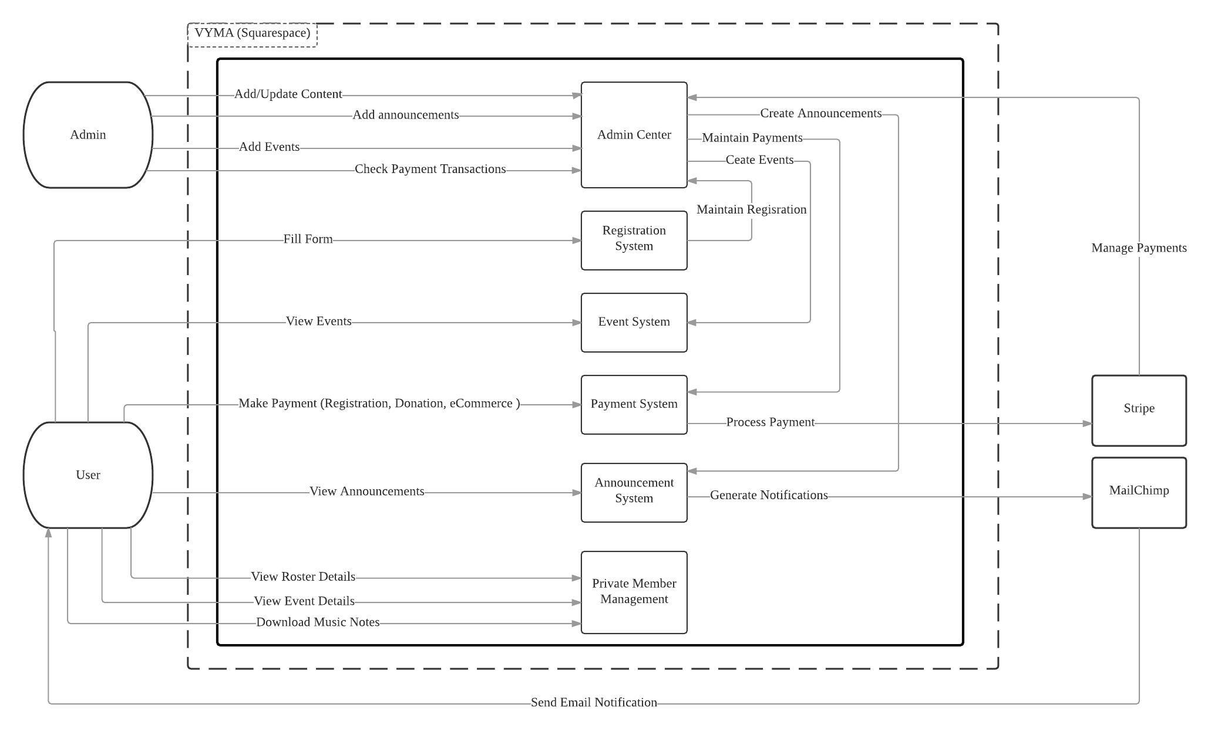

Figure 8: Element Relationship Diagram

##### Business Workflows

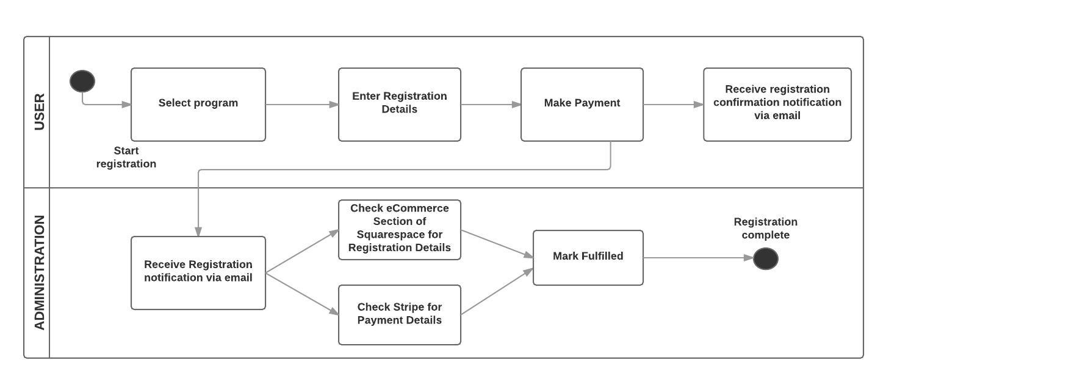

**Figure 9: Business Workflow: Online Registration and Payment System**

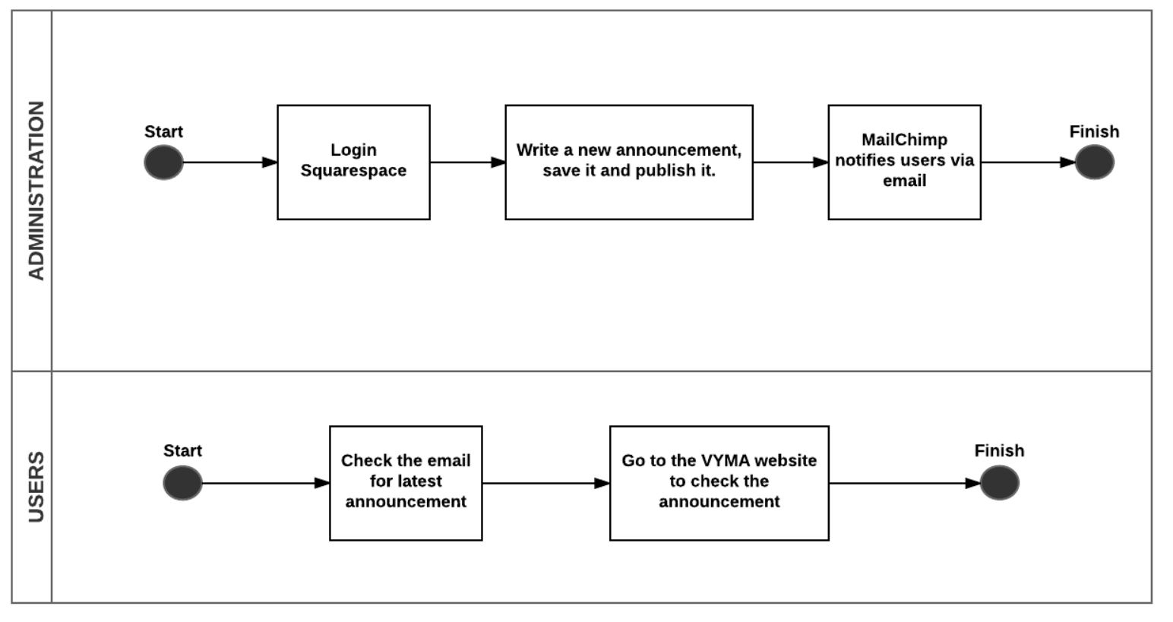

**Figure 10: Business Workflow: Announcement and Notification System**

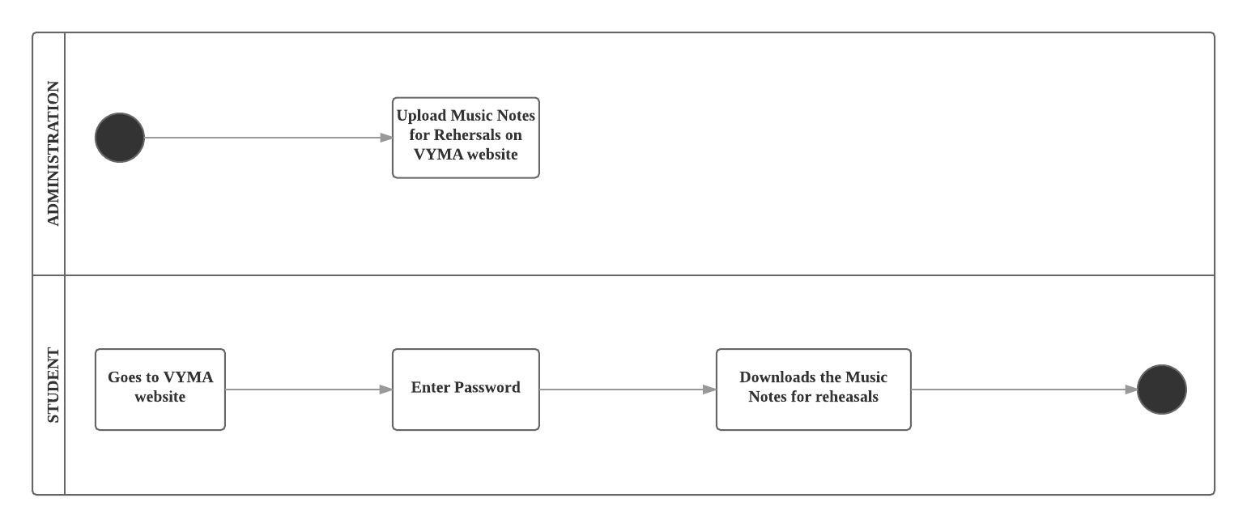

**Figure 11: Business Workflow: Download Music Notes**

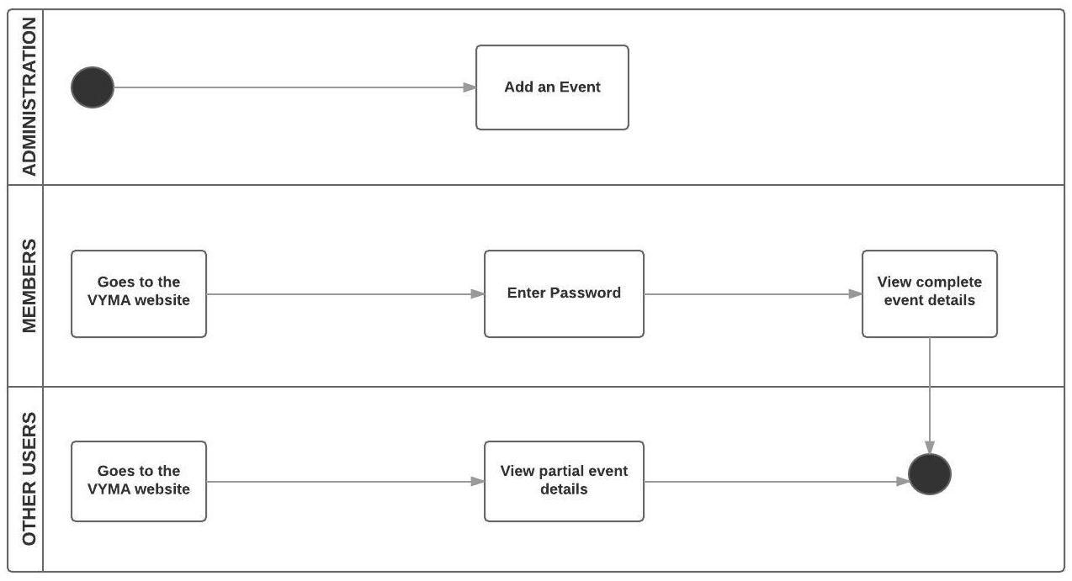

**Figure 12: Business Workflow: Calendar of Events**

#### Organizational and Operational Implications

##### 3.4.1 Organizational Transformations

Examples of organizational transformations:

* As the functionalities and capabilities of 3 websites are getting combined into one, redundancy in the content is eliminated.
* The maintainer will have to understand the features provided by Squarespace to add/modify the website.

##### Operational Transformations

* The new online registration and payment system provided in this new system eliminates the current manual, cumbersome and time consuming process of registration.
* The automatic email notifications generated when any announcements are posted on the website replaces the manual efforts of sending emails individually to all the members by the program coordinator.